DATA SCHEMA
I installed the MySQL server and started creating tables.
Data base: cognizant_practice
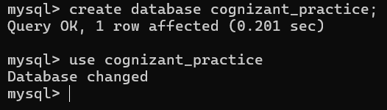
Next I created the table users
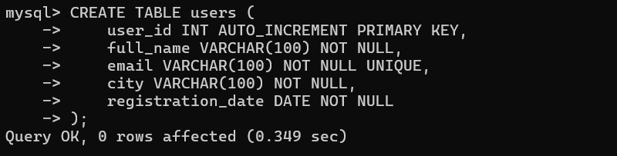
Then I created the events table
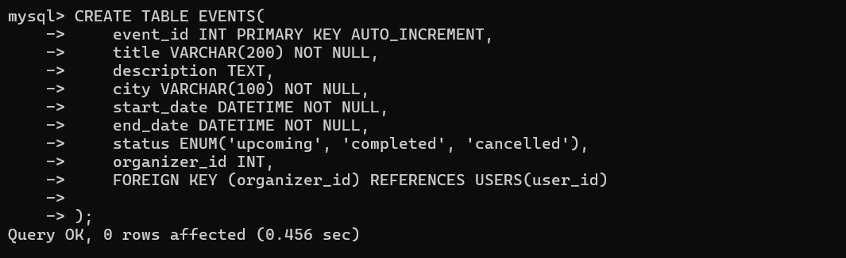
Then I created the sessions table
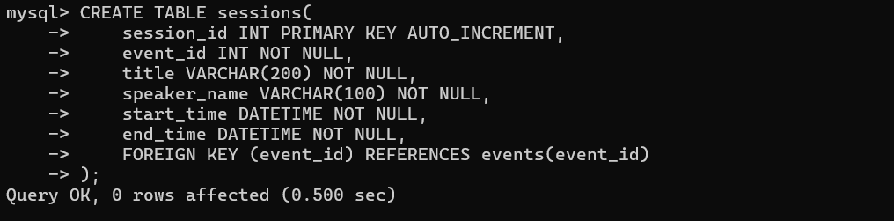
After I created the Registrations table
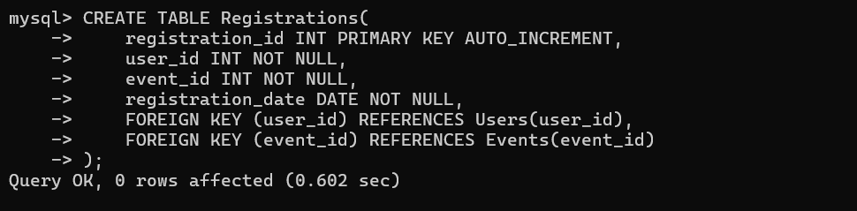
After I created the Feedback table
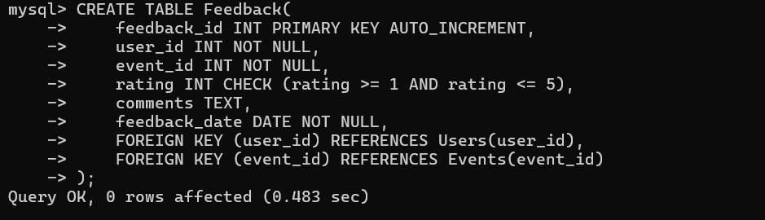
After I created the Resources table
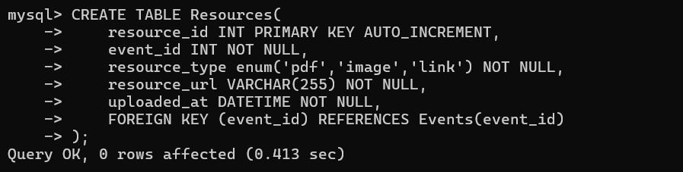
mysql> create database cognizant_practice;
Query OK, 1 row affected (0.201 sec)
mysql> use cognizant_practice
Database changed

USERS TABLE:
mysql> CREATE TABLE users (
user_id INT AUTO_INCREMENT PRIMARY KEY,
full_name VARCHAR(100) NOT NULL,
email VARCHAR(100) NOT NULL UNIQUE,
city VARCHAR(100) NOT NULL,
registration_date DATE NOT NULL
);
Query OK, 0 rows affected (0.349 sec)
EVENTS TABLE:
mysql> CREATE TABLE EVENTS(
event_id INT PRIMARY KEY AUTO_INCREMENT,
title VARCHAR(200) NOT NULL,
description TEXT,
city VARCHAR(100) NOT NULL,
start_date DATETIME NOT NULL,
end_date DATETIME NOT NULL,
status ENUM('upcoming', 'completed', 'cancelled'),
organizer_id INT,
FOREIGN KEY (organizer_id) REFERENCES USERS(user_id)
);
Query OK, 0 rows affected (0.456 sec)

SESSIONS TABLE
mysql> CREATE TABLE sessions(
session_id INT PRIMARY KEY AUTO_INCREMENT,
event_id INT NOT NULL,
title VARCHAR(200) NOT NULL,
speaker_name VARCHAR(100) NOT NULL,
start_time DATETIME NOT NULL,
end_time DATETIME NOT NULL,
FOREIGN KEY (event_id) REFERENCES events(event_id)
);
Query OK, 0 rows affected (0.500 sec)
REGISTRATION TABLE:
mysql> CREATE TABLE Registrations(
registration_id INT PRIMARY KEY AUTO_INCREMENT,
user_id INT NOT NULL,
event_id INT NOT NULL,
registration_date DATE NOT NULL,
FOREIGN KEY (user_id) REFERENCES Users(user_id),
FOREIGN KEY (event_id) REFERENCES Events(event_id)
);
Query OK, 0 rows affected (0.602 sec)

FEEDBACK TABLE:
mysql> CREATE TABLE Feedback(
feedback_id INT PRIMARY KEY AUTO_INCREMENT,
user_id INT NOT NULL,
event_id INT NOT NULL,
rating INT CHECK (rating >= 1 AND rating <= 5),
comments TEXT,
feedback_date DATE NOT NULL,
FOREIGN KEY (user_id) REFERENCES Users(user_id),
FOREIGN KEY (event_id) REFERENCES Events(event_id)
);
Query OK, 0 rows affected (0.483 sec)
RESOURCES TABLE:
mysql> CREATE TABLE Resources(
resource_id INT PRIMARY KEY AUTO_INCREMENT,
event_id INT NOT NULL,
resource_type enum('pdf','image','link') NOT NULL,
resource_url VARCHAR(255) NOT NULL,
uploaded_at DATETIME NOT NULL,
FOREIGN KEY (event_id) REFERENCES Events(event_id)
);
Query OK, 0 rows affected (0.413 sec)

Inserting the data into the tables we created above
INSERT INTO Users (user_id, full_name, email, city, registration_date)
VALUES
(1, 'Alice Johnson', 'alice@example.com', 'New York', '2024-12-01'),
(2, 'Bob Smith', 'bob@example.com', 'Los Angeles', '2024-12-05'),
(3, 'Charlie Lee', 'charlie@example.com', 'Chicago', '2024-12-10'),
(4, 'Diana King', 'diana@example.com', 'New York', '2025-01-15'),
(5, 'Ethan Hunt', 'ethan@example.com', 'Los Angeles', '2025-02-01');
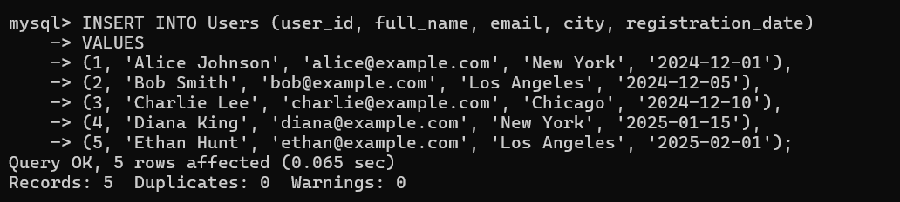
INSERT INTO Events VALUES
(1,'Tech Innovators Meetup','A meetup for tech enthusiasts.','New York','2025-06-10 10:00:00','2025-06-10 16:00:00','upcoming',1),
(2,'AI & ML Conference','Conference on AI and ML advancements.','Chicago','2025-05-15 09:00:00','2025-05-15 17:00:00','completed',3),
(3,'Frontend Development Bootcamp','Hands-on training on frontend technologies.','Los Angeles','2025-07-01 10:00:00','2025-07-03 16:00:00','upcoming',2);
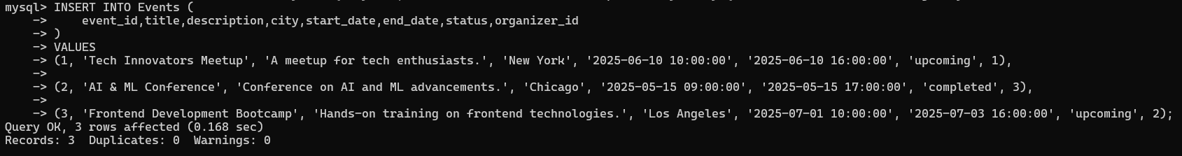
INSERT INTO Sessions VALUES
(1,1,'Opening Keynote','Dr. Tech','2025-06-10 10:00:00','2025-06-10 11:00:00'),
(2,1,'Future of Web Dev','Alice Johnson','2025-06-10 11:15:00','2025-06-10 12:30:00'),
(3,2,'AI in Healthcare','Charlie Lee','2025-05-15 09:30:00','2025-05-15 11:00:00'),
(4,3,'Intro to HTML5','Bob Smith','2025-07-01 10:00:00','2025-07-01 12:00:00');
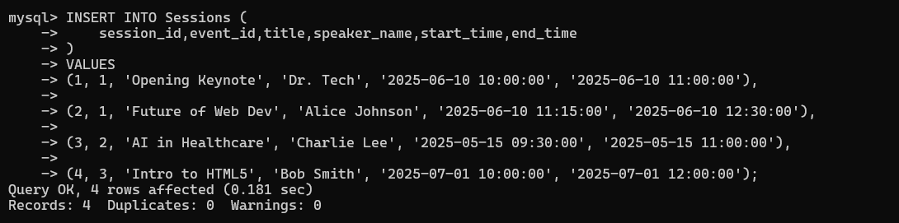
INSERT INTO Registrations VALUES
(1,1,1,'2025-05-01'),
(2,2,1,'2025-05-02'),
(3,3,2,'2025-04-30'),
(4,4,2,'2025-04-28'),
(5,5,3,'2025-06-15');
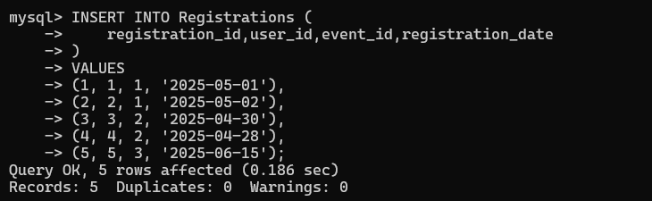
INSERT INTO Feedback VALUES
(1,3,2,4,'Great insights!','2025-05-16'),
(2,4,2,5,'Very informative.','2025-05-16'),
(3,2,1,3,'Could be better.','2025-06-11');
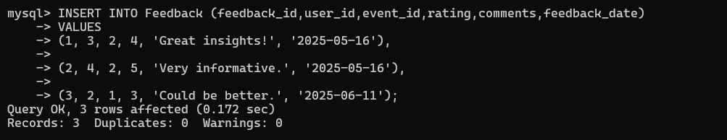

INSERT INTO Resources VALUES
(1,1,'pdf','https://portal.com/resources/tech_meetup_agenda.pdf','2025-05-01 10:00:00'),
(2,2,'image','https://portal.com/resources/ai_poster.jpg','2025-04-20 09:00:00'),
(3,3,'link','https://portal.com/resources/html5_docs','2025-06-25 15:00:00');
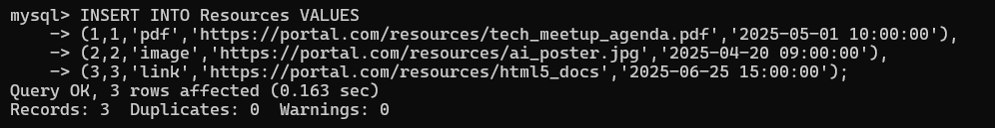

EXERCISE :
1. User Upcoming Events
Show a list of all upcoming events a user is registered for in their city, sorted by date.
Ans) SELECT u.full_name, e.title,e.city,e.start_date
FROM Users u
JOIN Registrations r ON u.user_id = r.user_id
JOIN Events e ON r.event_id = e.event_id
WHERE e.status = 'upcoming'
AND u.city = e.city
ORDER BY e.start_date;
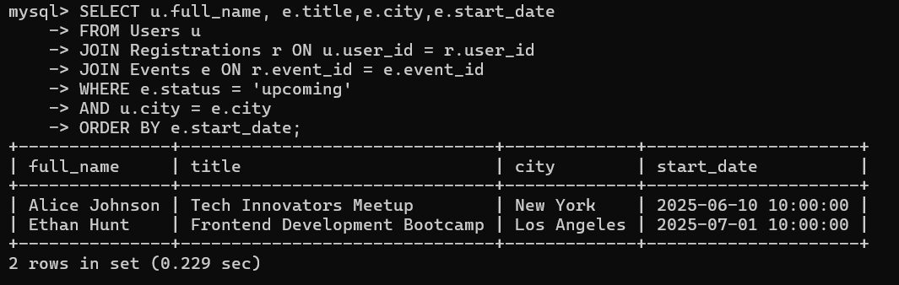
2. Top Rated Events
Identify events with the highest average rating, considering only those that have received at least 10 feedback submissions.

Ans) SELECT e.event_id, e.title,AVG(f.rating) AS avg_rating,COUNT(*) AS feedback_count
FROM Events e
JOIN Feedback f ON e.event_id = f.event_id
GROUP BY e.event_id, e.title
HAVING COUNT(*) >= 10
ORDER BY avg_rating DESC;
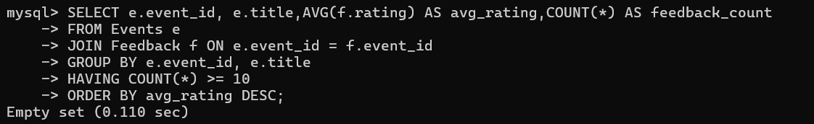
3. Inactive Users
Retrieve users who have not registered for any events in the last 90 days.
Ans) SELECT *
FROM Users u
WHERE NOT EXISTS (
SELECT 1
FROM Registrations r
WHERE r.user_id = u.user_id
AND r.registration_date >= CURDATE() - INTERVAL 90 DAY
);
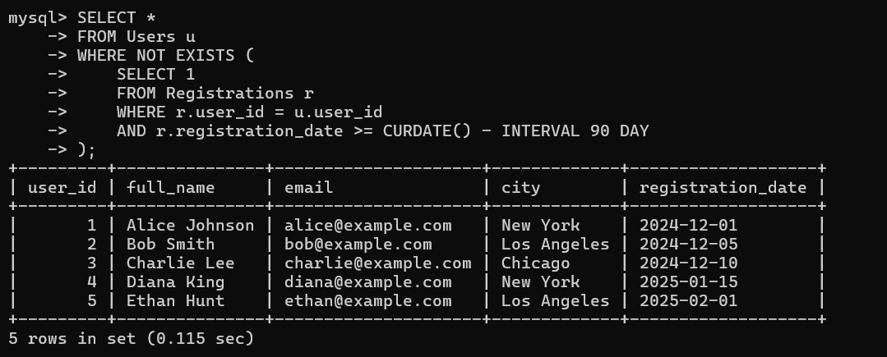
4. Peak Session Hours
Count how many sessions are scheduled between 10 AM to 12 PM for each event.

Ans) SELECT e.title,
COUNT(s.session_id) AS session_count
FROM Events e
LEFT JOIN Sessions s
ON e.event_id = s.event_id
AND TIME(s.start_time) BETWEEN '10:00:00' AND '12:00:00'
GROUP BY e.event_id, e.title;
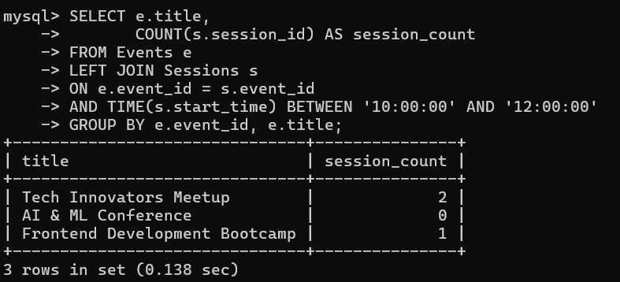
5. Most Active Cities
List the top 5 cities with the highest number of distinct user registrations.
Ans) SELECT u.city,
COUNT(DISTINCT r.user_id) AS total_users
FROM Users u
JOIN Registrations r
ON u.user_id = r.user_id
GROUP BY u.city
ORDER BY total_users DESC
LIMIT 5;
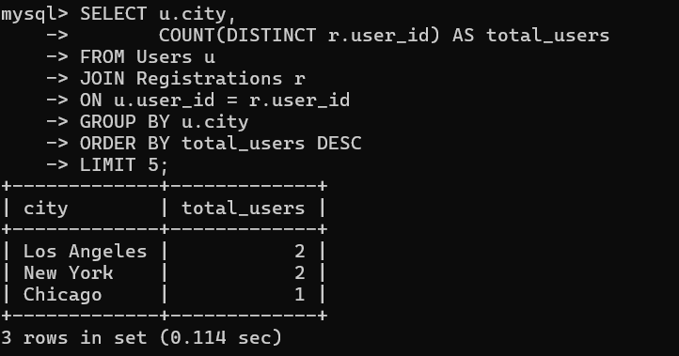
6. Event Resource Summary
Generate a report showing the number of resources (PDFs, images, links) uploaded for each event.
Ans) SELECT e.title,
SUM(CASE WHEN resource_type='pdf' THEN 1 ELSE 0 END) AS pdfs,
SUM(CASE WHEN resource_type='image' THEN 1 ELSE 0 END) AS images,
SUM(CASE WHEN resource_type='link' THEN 1 ELSE 0 END) AS links
FROM Events e
LEFT JOIN Resources r
ON e.event_id = r.event_id
GROUP BY e.event_id,e.title;
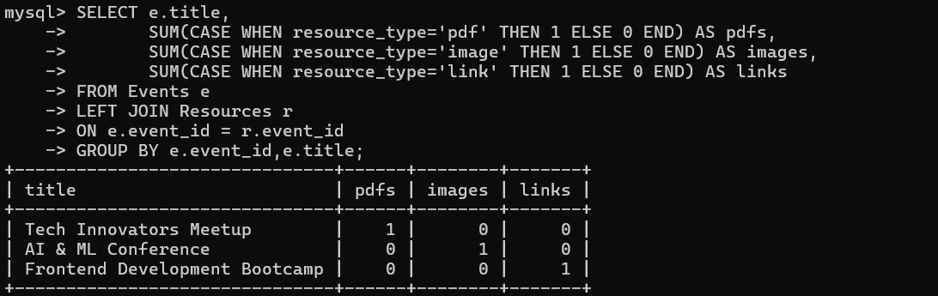

7. Low Feedback Alerts
List all users who gave feedback with a rating less than 3, along with their comments and associated event names.
Ans) SELECT u.full_name,e.title,f.rating,f.comments
FROM Feedback f
JOIN Users u
ON f.user_id = u.user_id
JOIN Events e
ON f.event_id = e.event_id
WHERE f.rating < 3;
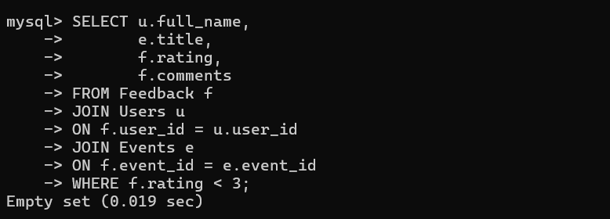
8. Sessions per Upcoming Event
Display all upcoming events with the count of sessions scheduled for them.
Ans)
SELECT e.title,
COUNT(s.session_id) AS total_sessions
FROM Events e
LEFT JOIN Sessions s
ON e.event_id = s.event_id
WHERE e.status = 'upcoming'
GROUP BY e.event_id,e.title;
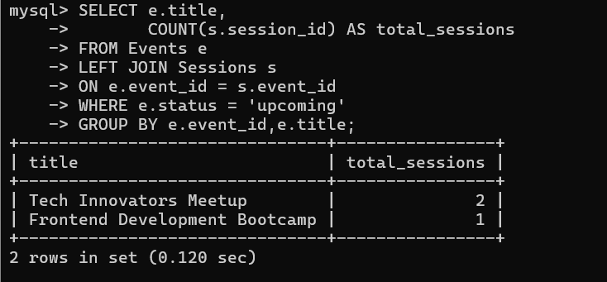
9. Organizer Event Summary
For each event organizer, show the number of events created and their current status (upcoming, completed, cancelled).
Ans) SELECT u.full_name,
e.status,
COUNT(*) AS total_events
FROM Users u
JOIN Events e
ON u.user_id = e.organizer_id
GROUP BY u.full_name,e.status;
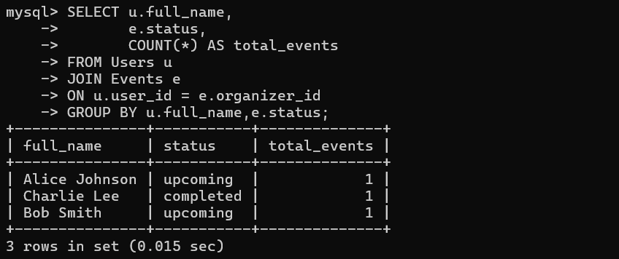

10. Feedback Gap
Identify events that had registrations but received no feedback at all.
Ans) SELECT e.event_id,
e.title
FROM Events e
JOIN Registrations r
ON e.event_id = r.event_id
LEFT JOIN Feedback f
ON e.event_id = f.event_id
WHERE f.feedback_id IS NULL
GROUP BY e.event_id,e.title;
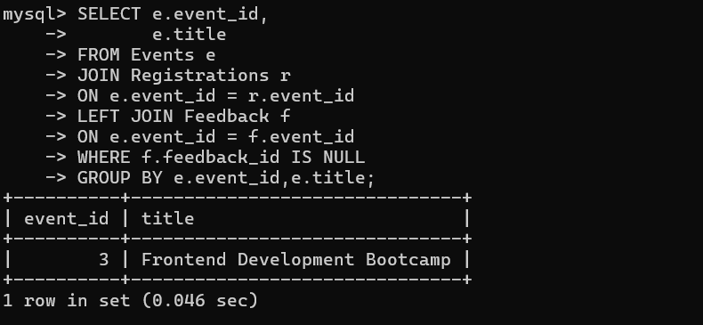
11. Daily New User Count
Find the number of users who registered each day in the last 7 days.
Ans) SELECT registration_date,
COUNT(*) AS total_users
FROM Users
WHERE registration_date >= CURDATE() - INTERVAL 7 DAY
GROUP BY registration_date
ORDER BY registration_date;
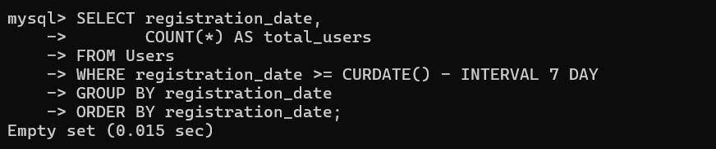
12. Event with Maximum Sessions
List the event(s) with the highest number of sessions.
Ans)SELECT e.title,
COUNT(s.session_id) AS total_sessions FROM Events e JOIN Sessions s
ON e.event_id = s.event_id GROUP BY e.event_id,e.title
HAVING COUNT(s.session_id) = (
SELECT MAX(session_count)
FROM (
SELECT COUNT(*) AS session_count
FROM Sessions
GROUP BY event_id
) x
);
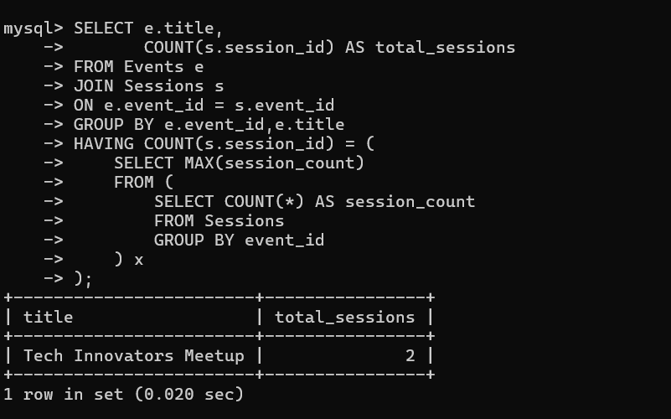
13. Average Rating per City
Calculate the average feedback rating of events conducted in each city.
Ans) SELECT e.city,
ROUND(AVG(f.rating),2) AS avg_rating
FROM Events e
JOIN Feedback f
ON e.event_id = f.event_id
GROUP BY e.city;
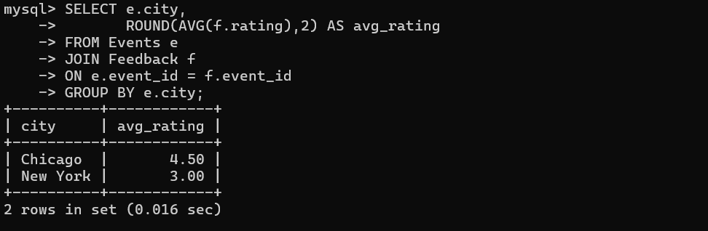
14. Most Registered Events
List top 3 events based on the total number of user registrations.
Ans) SELECT e.title,COUNT(r.registration_id) AS registrations
FROM Events e JOIN Registrations r
ON e.event_id = r.event_id
GROUP BY e.event_id,e.title ORDER BY registrations DESC
LIMIT 3;
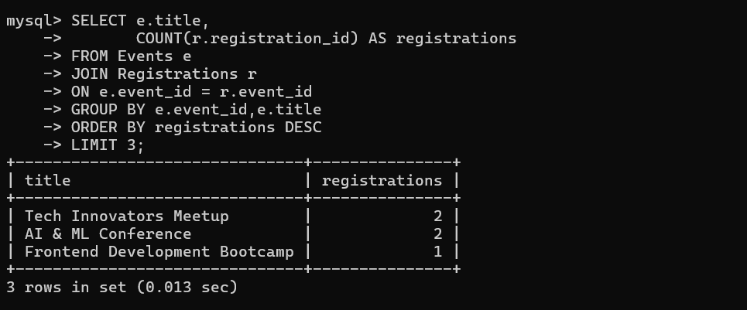
15. Event Session Time Conflict
Identify overlapping sessions within the same event (i.e., session start and end times that conflict).
Ans) SELECT s1.event_id,
s1.title AS session1,
s2.title AS session2
FROM Sessions s1
JOIN Sessions s2
ON s1.event_id = s2.event_id
AND s1.session_id < s2.session_id
AND s1.start_time < s2.end_time
AND s1.end_time > s2.start_time;
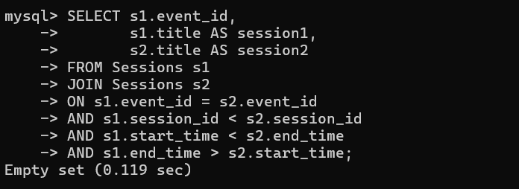
16. Unregistered Active Users
Find users who created an account in the last 30 days but haven’t registered for any events.
Ans) SELECT *
FROM Users u
WHERE u.registration_date >= CURDATE() - INTERVAL 30 DAY
AND NOT EXISTS (
SELECT 1
FROM Registrations r
WHERE r.user_id = u.user_id
);
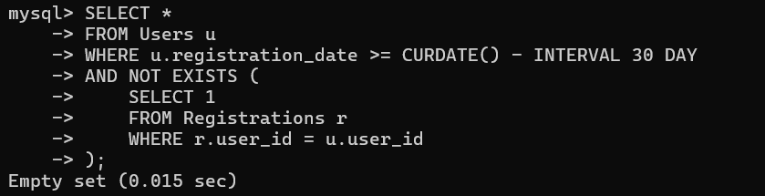
17. Multi-Session Speakers
Identify speakers who are handling more than one session across all events.
Ans) SELECT speaker_name,
COUNT(*) AS session_count
FROM Sessions
GROUP BY speaker_name
HAVING COUNT(*) > 1;
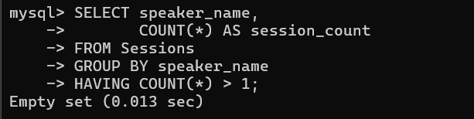
18. Resource Availability Check
List all events that do not have any resources uploaded.
Ans) SELECT e.event_id,
e.title
FROM Events e
LEFT JOIN Resources r
ON e.event_id = r.event_id
WHERE r.resource_id IS NULL;
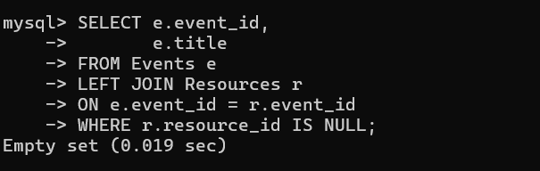
19. Completed Events with Feedback Summary
For completed events, show total registrations and average feedback rating.
Ans) SELECT e.title,
COUNT(DISTINCT r.registration_id) AS total_registrations,
ROUND(AVG(f.rating),2) AS avg_rating
FROM Events e
LEFT JOIN Registrations r
ON e.event_id = r.event_id
LEFT JOIN Feedback f
ON e.event_id = f.event_id
WHERE e.status = 'completed'
GROUP BY e.event_id,e.title;
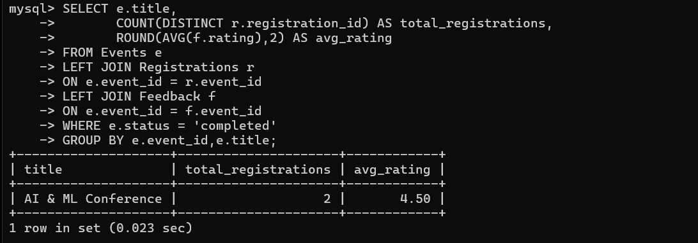
20. User Engagement Index
For each user, calculate how many events they attended and how many feedbacks they submitted.

Ans)
SELECT u.user_id,
u.full_name,
COUNT(DISTINCT r.event_id) AS attended_events,
COUNT(DISTINCT f.feedback_id) AS feedback_count
FROM Users u
LEFT JOIN Registrations r
ON u.user_id = r.user_id
LEFT JOIN Feedback f
ON u.user_id = f.user_id
GROUP BY u.user_id,u.full_name;
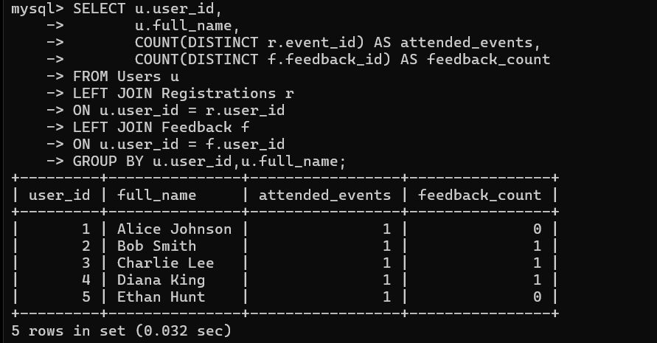
21. Top Feedback Providers
List top 5 users who have submitted the most feedback entries.
Ans) SELECT u.full_name,
COUNT(f.feedback_id) AS feedbacks FROM Users u
JOIN Feedback f
ON u.user_id = f.user_id
GROUP BY u.user_id,u.full_name
ORDER BY feedbacks DESC
LIMIT 5;
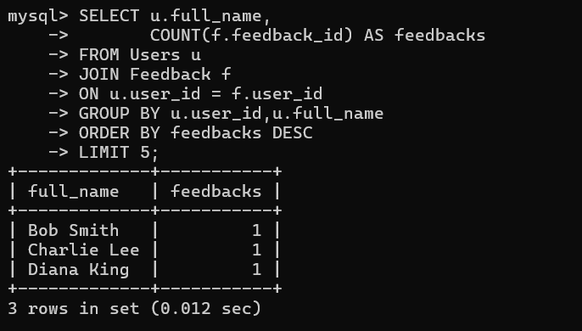
22. Duplicate Registrations Check
Detect if a user has been registered more than once for the same event.
Ans ) SELECT user_id,
event_id,
COUNT(*) AS duplicate_count
FROM Registrations
GROUP BY user_id,event_id
HAVING COUNT(*) > 1;
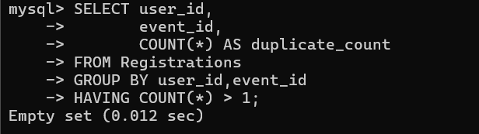

23. Registration Trends
Show a month-wise registration count trend over the past 12 months.

Ans) SELECT DATE_FORMAT(registration_date,'%Y-%m') AS month,
COUNT(*) AS registrations
FROM Registrations
WHERE registration_date >= CURDATE() - INTERVAL 12 MONTH
GROUP BY DATE_FORMAT(registration_date,'%Y-%m')
ORDER BY month;
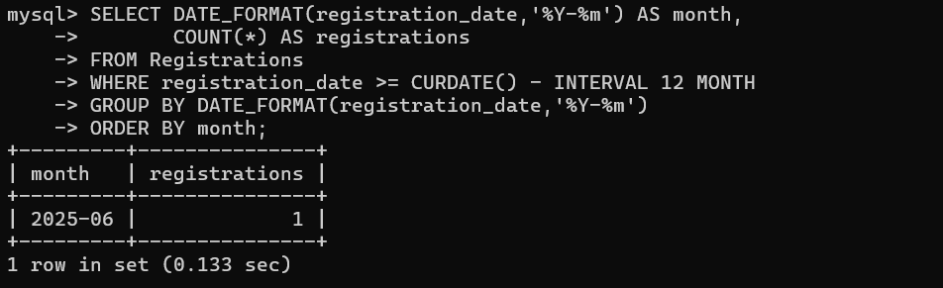
24. Average Session Duration per Event
Compute the average duration (in minutes) of sessions in each event.
Ans) SELECT e.title,
ROUND( AVG(TIMESTAMPDIFF(MINUTE, s.start_time, s.end_time)),2) AS avg_duration_minutes
FROM Events e
JOIN Sessions s
ON e.event_id = s.event_id
GROUP BY e.event_id,e.title;
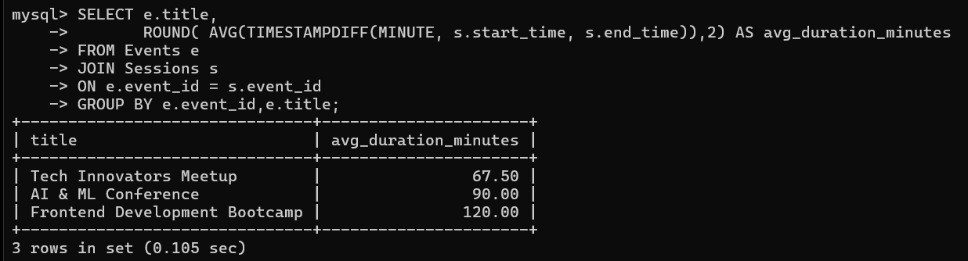
25. Events Without Sessions
List all events that currently have no sessions scheduled under them.

Ans) SELECT e.event_id,
e.title
FROM Events e
LEFT JOIN Sessions s
ON e.event_id = s.event_id
WHERE s.session_id IS NULL;
